Laboratory work 2

Please write your answers to the pdf file for defence:

1. Explain the difference between DDL and DML, give the following examples:
   1. at least 3 DDL commands;

DDL - is used to specify the database schema database structure

-- CREATE  
CREATE TABLE KBTU(  
 faculty_id varchar(10),  
 faculty_name varchar(50),  
 num_of_professors int,  
 num_of_students int  
);  
  
-- ALTER  
ALTER TABLE KBTU  
 ADD COLUMN fac_dean varchar(50);  
  
-- DROP  
DROP TABLE KBTU;

* 1. at least 4 DML commands.

DML - is used to access, modify or retrieve the data from the database

INSERT INTO KBTU VALUES ('5','IT',200,3500);  
  
UPDATE KBTU SET faculty_name = 'BS' WHERE faculty_name = 'IT';  
  
SELECT num_of_professors FROM KBTU WHERE faculty_id = '5';  
  
DELETE FROM KBTU WHERE faculty_name = 'BS';

1. Write SQL statements to create tables in the figure below:

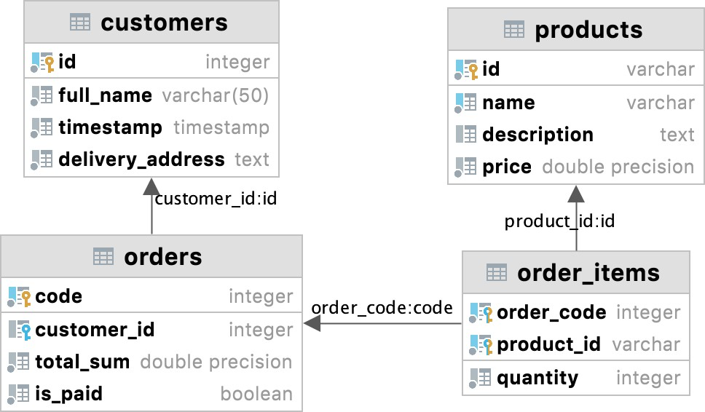

*grey circle - not null, blue column - unique; quantity, total_sum, price > 0*

1. Write SQL statements describing tables with appropriate ***data types*** and ***constraints*** satisfying the following conditions*(maybe you need additional tables to store data* ***atomically*** *and* ***efficiently****)*:
   1. a students table storing data such as full name, age, birth date, gender, average grade, information about yourself, the need for a dormitory, additional info.
   2. an instructors table storing data such as full name, speaking languages, work experience, the possibility of having remote lessons.
   3. a lesson participants table storing data such as lesson title, teaching instructor, studying students, room number.
2. Give examples of insertion, update and deletion of data on tables from exercise 2.

Note: you can test your queries in datagrip